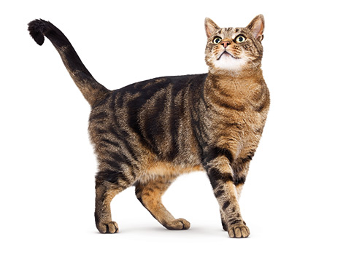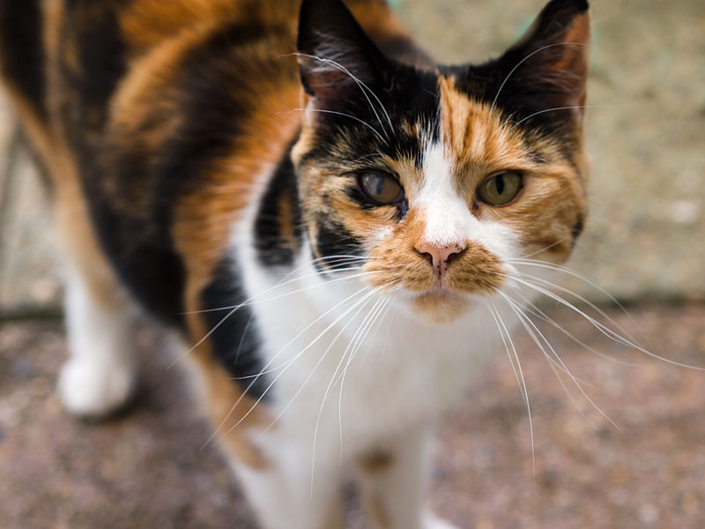<https://commons.wikimedia.org/wiki/File:Tortoiseshell_cat_(9665916133).jpg> (cat left)

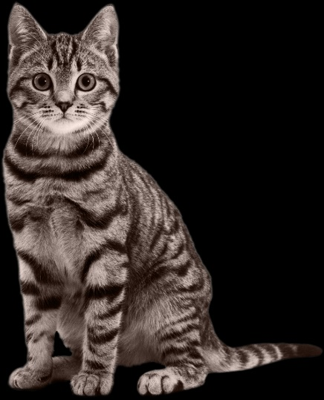<https://www.royalcanin.com/products/cat/adult> (cat above right)

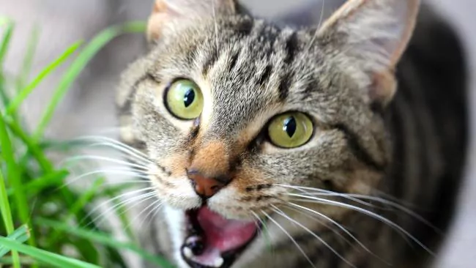 <http://www.alsointocats.com/popular-cat-names/> (grey cat left)

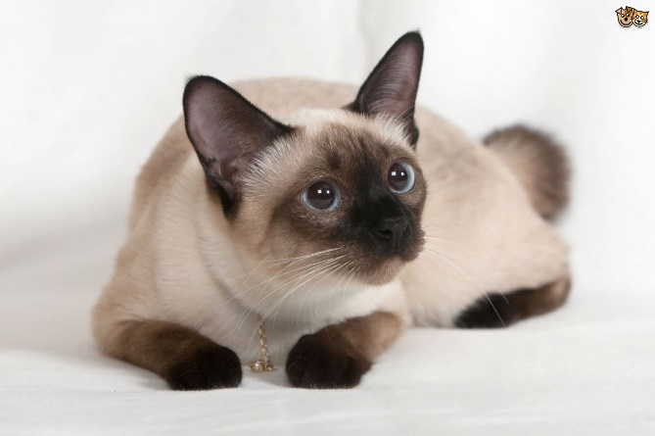<http://www.news.com.au/lifestyle/real-life/wtf/stray-cat-prime-suspect-in-attempted-murder-of-elderly-japanese-woman/news-story/503ef4a1a972085131efd7946a382280> (cat green eyes above)

<https://www.pets4homes.co.uk/pet-advice/common-cat-coat-patterns-explained.html> (cat left)